

SYNKRON KNIGHTS

HTPS - Agentic AI based real time cross jurisdictional risk modeling solution

Team Details:
2000156676 – Sai vighnessh B L
2000156678 – Keerthika R
2000156690 – Hemashri S
2000156696 – Karthikram Prabhakar

1. Solution Document

Project Summary
Synkron Knights is an AI-powered Legal Risk Intelligence system designed to analyze unstructured business or regulatory text and provide a clear, actionable risk assessment. The system evaluates jurisdictional exposure, applicable laws, compliance risks, and comparable real-world cases, enabling faster and more informed decision-making for compliance, legal, and business teams. The solution converts complex regulatory analysis into plain-English insights, reducing manual legal effort and ensuring consistency in risk evaluation.

Technology Used and Versions
Frontend
- HTML5
- CSS3
- JavaScript
Backend
- Python 3.10
- Flask 2.3
AI / NLP
- OpenAI GPT-4-O-mini
Deployment / Tools
- VS Code

AI Used and Version
- Model: OpenAI GPT-4 / GPT-4.1
- Type: Large Language Model (LLM)
- Usage: Legal text understanding, risk classification, reasoning, summarization

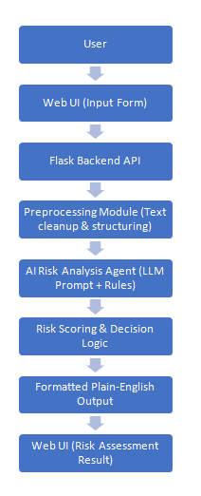
Technical Architecture

Modules Used
- User Interface Module
- Backend Controller (Flask Routes)
- Text Preprocessing Module
- AI Risk Analysis Module
- Risk Scoring & Decision Engine
- Response Formatter

Flow Diagram (Step-by-Step)
- User enters regulatory or business scenario text
- Frontend sends text to backend API
- Backend preprocesses input text
- AI engine analyzes risks using trained prompt logic
- Risk score and compliance decision are generated
- Final response is formatted into readable output
- Result is displayed on the dashboard

Dataset Used for AI Training
This project uses a pre-trained Large Language Model.
No custom model training was performed.
However, reference datasets were used for prompt grounding:
- Public regulatory texts (GDPR, DPDP Act, IT Act, HIPAA summaries)
- Compliance guidelines (FATF, SEC, RBI, ISO excerpts)
- Publicly available legal case summaries
- Sample risk assessment documents
These datasets were used indirectly for prompt engineering and validation, not model retraining.

2. Coding Details

Module-wise Explanation

1. UI Module
- Captures user input text
- Displays loading indicator while processing
- Shows final risk analysis in plain English

2. Backend Controller
- Handles API requests
- Manages request validation
- Routes data between UI and AI engine

3. Text Preprocessing Module
- Removes unwanted characters
- Normalizes text
- Identifies key entities like country, sector, and activity

4. AI Risk Analysis Module
- Sends structured prompt to LLM
- Ensures consistent output format
- Extracts risks, laws, and decisions

5. Risk Scoring Engine
- Converts qualitative risks into numeric score (0–100)
- Categorizes risk as Low / Medium / High

6. Response Formatter
- Converts AI output into user-friendly plain English
- Ensures no JSON, markdown, or symbols
- Maintains professional tone

Technique Used for AI Training
- Prompt Engineering
- Few-shot learning via structured examples
- Rule-based risk scoring layered on top of LLM reasoning
- Human-in-the-loop validation during testing
No fine-tuning or model retraining was performed.

3. Final Outcome

Deliverables
- A working AI-based Legal Risk Intelligence web application
- Clean and readable risk analysis output
- Dashboard covering insights.
- Exportable Analysis(as .pdf)

Project Folder Structure
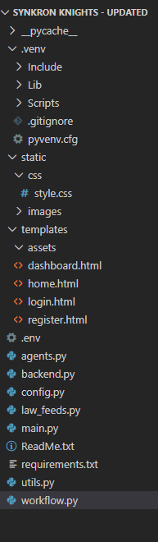

Functionalities

Login Page:
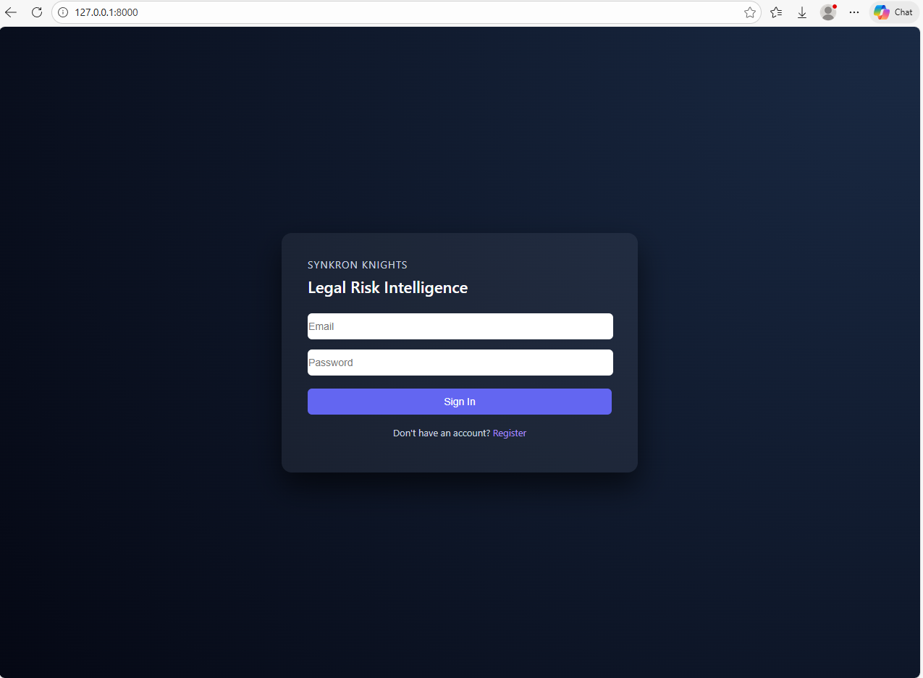

Register Page:
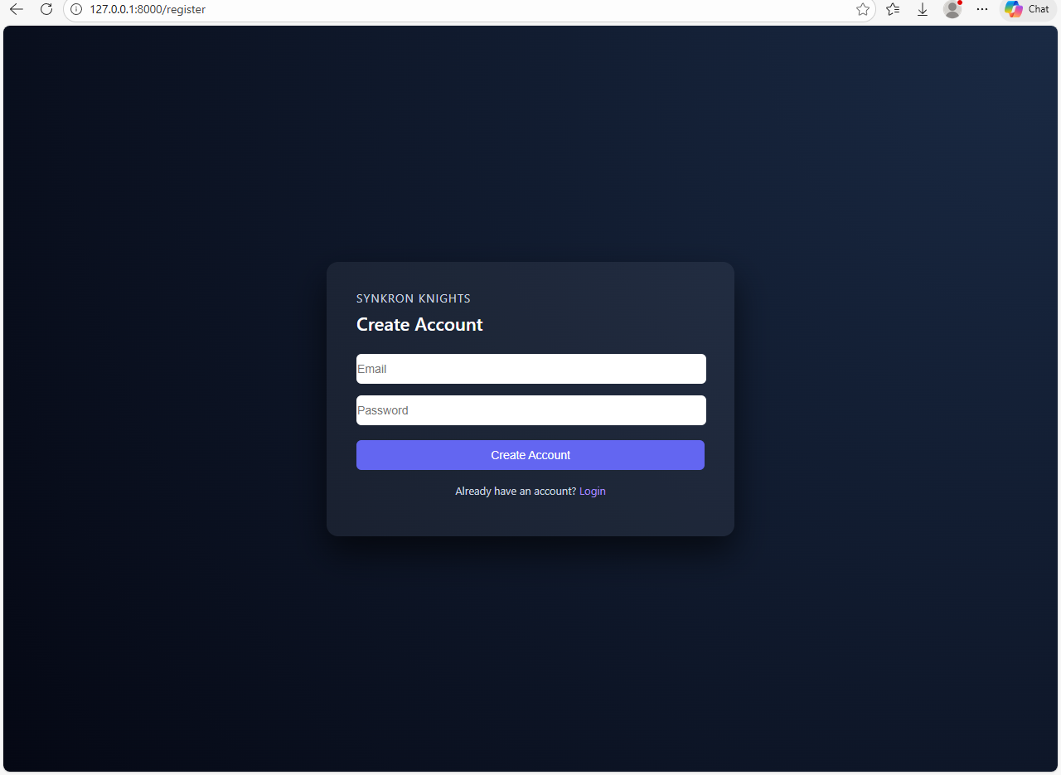

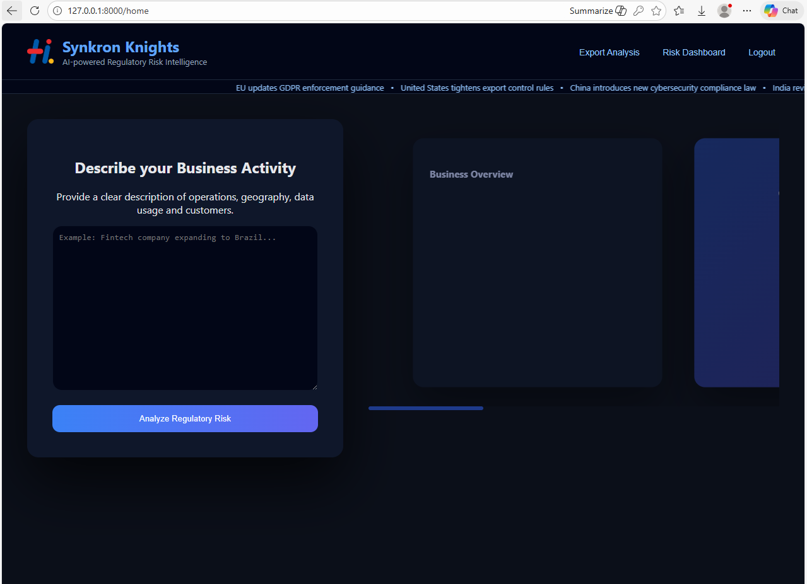
Home Page:

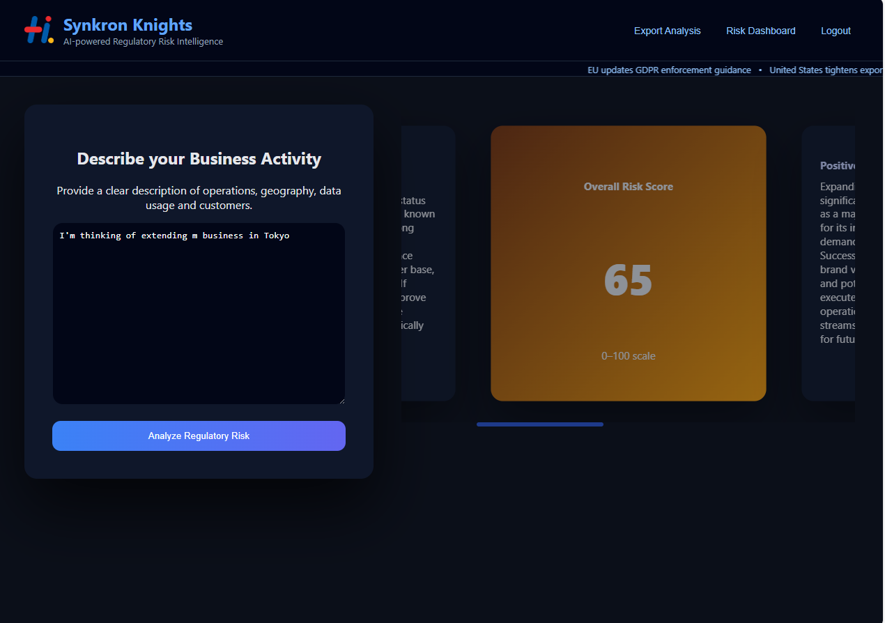
Risk Score:

Exported Analysis pdf:

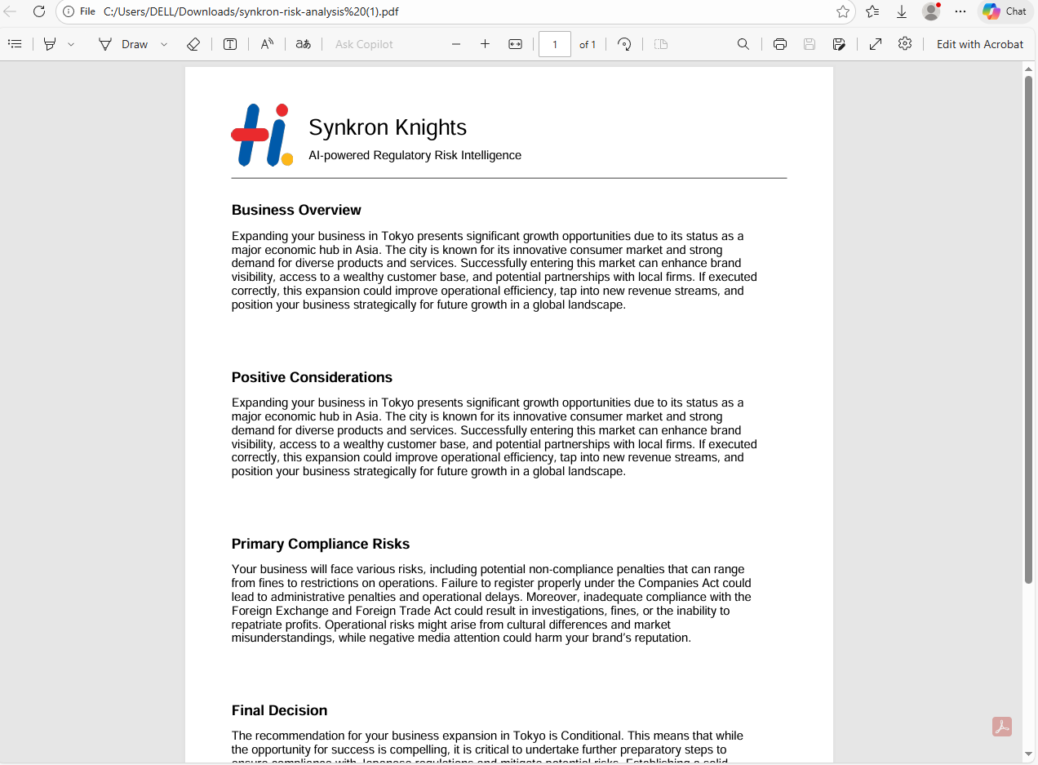

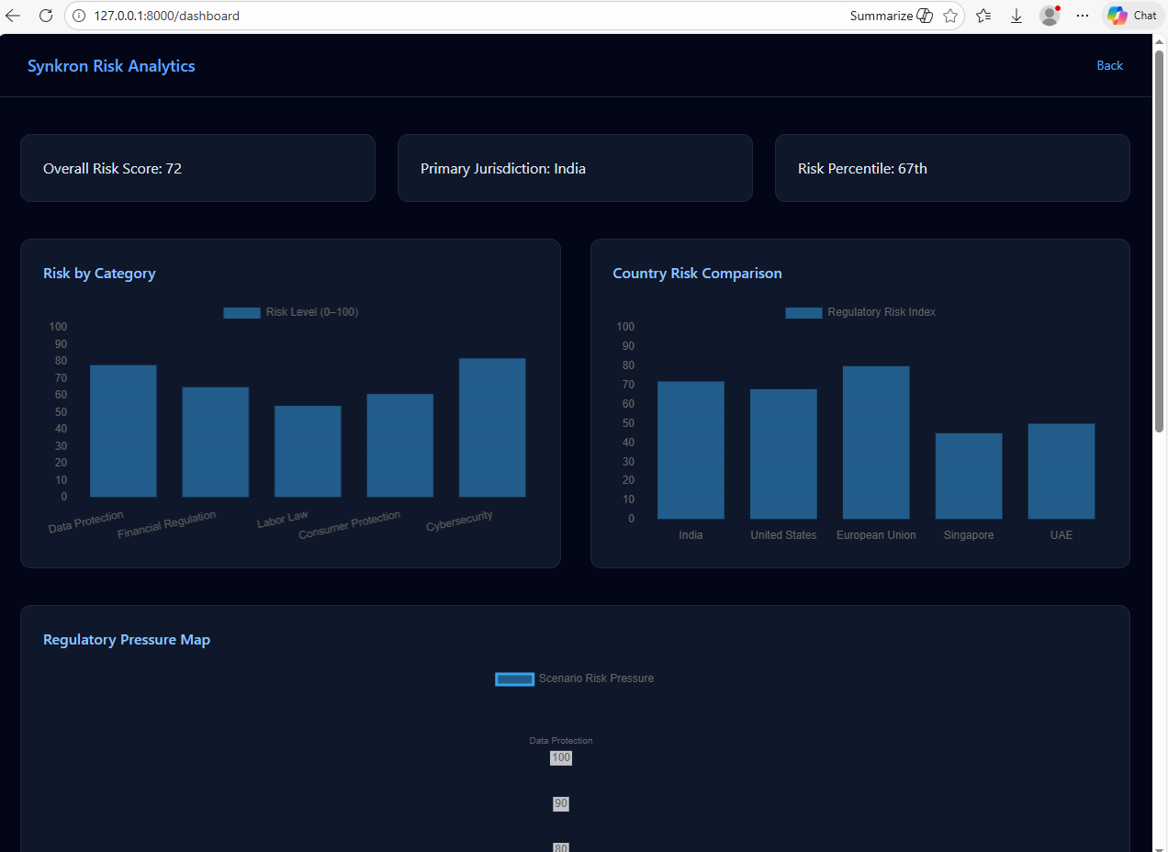
Risk Analytics Page:

